Dictionary to json:

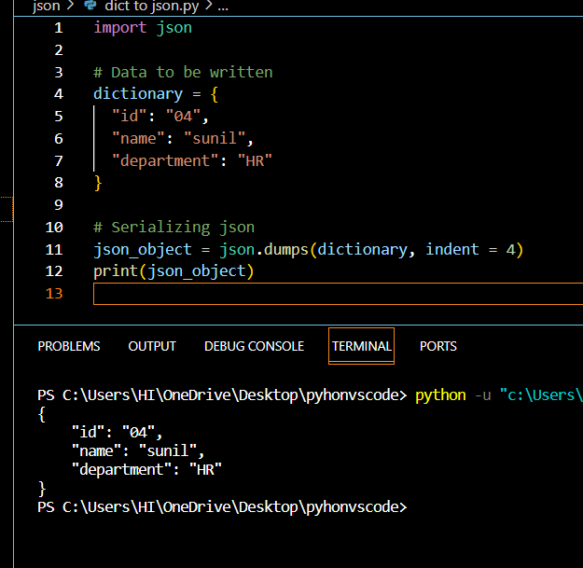

Json string to dict:

Writing to json:

Numpy:

NumPy is a general-purpose array-processing package. It provides a high-performance multidimensional array object and tools for working with these arrays. It is the fundamental package for scientific computing with Python. It is open-source software.



